Experiment no : 02
Experiment Name : Working with Differentiation, Integration and Matrix in Matlab.

Problem 1 :
Solve a differentiation and an integration problem in Matlab.

Problem analysis :

- Declaration of symbolic veritable
- Writing the differentiation and integration equation
- Use diff() and int() function for differentiation and integration respectively

Coding :

clc
clear
%% Differentiation
syms x f;
f = x^2 - 2; % Equation
disp('Differentiation of : (x^2 - 2) With respect to x');
disp(diff(f,x));
%% Integration
f = x^2 - 3; % Equation
disp('Integration of : (x^2 - 3) With Lower limit 0 & Upper limit 1');
disp(int(f,0,1));

Output :
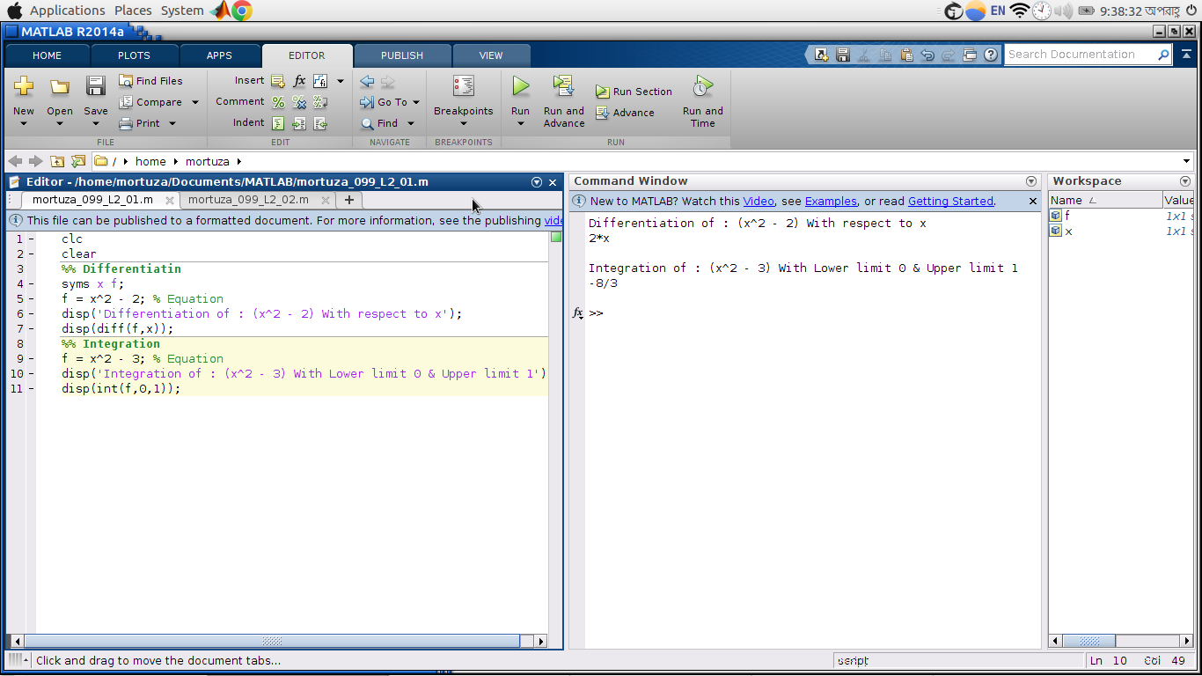

Problem 2 :
Manipulation of matrix in Matlab.

Problem analysis :
- Declaration of matrix
- Display the matrix
- Show the transpose of matrix
- Show the inverse of matrix
- Show the . Multiplication of matrix
- Show the * multiplication of matrix

Coding :

clc
clear
a = [1 2;3 4];
b = [5 6;7 8];
disp('Matrix A');
disp(a);
disp('Matrix B');
disp(b);
% Transpose
disp('Transpose Matrix');
disp(a');
% Inverse
disp('Inverse Matrix');
disp(inv(a));
% .Multiplication
disp('. Multiplication');
disp(a.*b);
% *Multiplication
disp('* Multiplication');
disp(a*b);

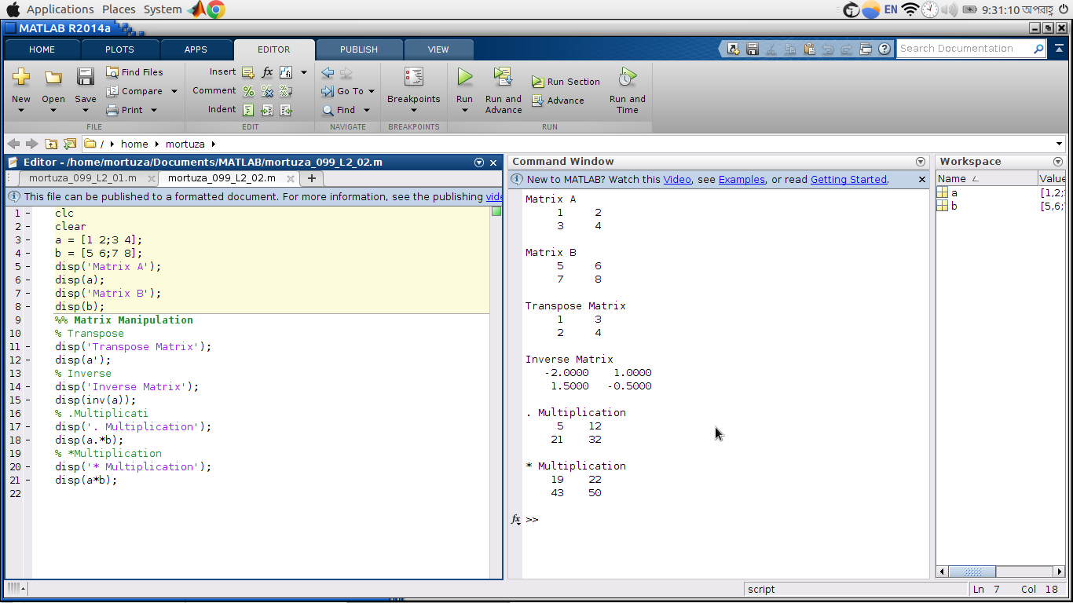
Output :

Inverse Matrix Step by Step:
